Institutional Matrices Theory and Russian Reforms
(new shorter version)

Svetlana Kirdina

Doctor of Sociology
Russian Academy of Sciences, Institute of Economics

32, Nakhimovskiy prosp., Institute of Economics RAS,
Moscow, 117218 Russia

e-mail: kirdina@inecon.ru web-site: www.kirdina.ru

The attempts to use well-known theories to understand and forecast Russian reforms of 1985-2000 have failed. Therefore new concepts are put forward by Russian academics, and the institutional matrices theory developed by author is one of them. .
This theory, regards the society as a structured whole with three main spheres – economy, policy and ideology, which are morphologically interconnected. Thus social relations forming the inherent structure include the following :
- economic interrelations related to resources used for the reproduction of social entities;
- political, i.e. regular and organized social actions to achieve the defined objectives; and
- ideological interrelations embodying important social ideas and values.
Basic institutions are the subject of analysis. They are permanently reproducing staples of social relations in different civilizations and historical periods. Basic institutions integrate the society into one whole that is developing, sometimes with conflicts. Institutions have a dual natural-artificial character. On the one hand, institutions manifest self-organization mechanisms of the society as natural social system. On the other hand, institutions are the result of human reflexion with regard to relevant laws and rules; they emerge as human-made entities.
We define aggregations of interrelated basic economic, political and ideological institutions as institutional matrices. Historical observations and empirical research as well as mathematical modeling give ground to the hypothesis about two types of institutional matrices, namely X-matrices and Y-matrices.
An X-matrix is formed by institutions of redistributive economy (Karl Polanyi’s term), unitary political order and communitarian ideology with a priority of “We” over “I”. An Y-matrix is formed by institutions of market economy, federative political order and the ideology of subsidiarity, i.e. a priority of “I” over “We” (Picture 1).

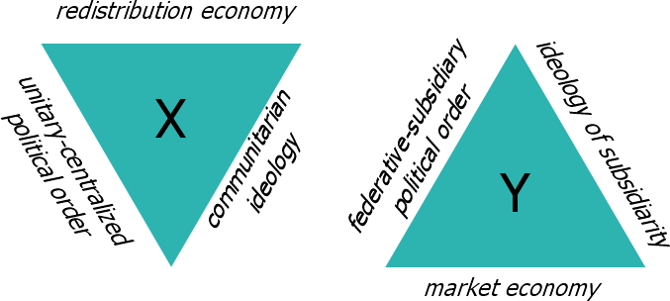

Picture 1. X- and Y- matrices structure.

In real-life societies X- and Y-matrices interact, with one of them permanently prevailing. Dominant institutions of the prevailing matrix define the nature of society and serve as framework of performance for complementary institutions from another matrix (Picture 2).

Y
X

X
Y

Picture 2. Balances of dominant and complementary institutional matrices.

Structures and functions of basic institutions in X- and Y-matrices are presented in Tables 1-3.

Table 1. Economic institutions

Functions of institutions | Institutions of redistributive economy in X-matrix | Institutions of market economy in Y-matrix
Fixing of goods (property rights system) | Supreme conditional ownership | Private ownership
Transfer of goods | Redistribution (accumulation-coordination-distribution) | Exchange (buying-selling)
Interactions between economic agents | Cooperation | Competition
Labor system | Employed (unlimited-term) labor | Contract (short- and medium-term) labor
Feed-back (effectiveness indices) | Cost limitation  (Х-efficiency) | Profit maximization  (Y- efficiency)

It appears that same economic functions are instrumented by specific institutions in different matrices.

Table 2. Political institutions
Functions of institutions | Institutions of unitary political order in X-matrix | Institutions federative political order in Y- matrix
Territorial administrative organization of the state | Administrative division  (unitarity) | Federative structure (federation)
Governance system (flow of decision making) | Vertical hierarchical authority with Center on the top | Self-government and subsidiarity
Type of interaction in the order of decision making | General assembly and unanimity | Multi-party system and democratic majority
Filling of governing positions | Appointment | Election
Feed-back | Appeals to higher levels of hierarchical authority | Law suits

There are 5 basic economic and political institutions and 3 ideological.

Table 3. Ideological institutions

Functions of institutions | Institutions of communitarian ideology in X-matrix | Institutions of subsidiary ideology in Y-матрицы
Driver of social actions | Collectivism | Individualism
Normative understanding of social structure | Egalitarianism | Stratification
Prevailing social values | Order | Freedom
The type of the material and technological environment is the key determinant of either X-matrix or Y-matrix. The environment can be a communal indivisible system, where removal of some elements can lead to disintegration of the whole system, - or it can be non-communal with possibilities of its technological dissociation. In a communal environment the institutions of X-matrix are dominant whereas Y-matrix institutions are complementary. In a non-communal environment it is vice versa.
We suppose that X-matrix prevails in Russia, China, most Asian and Latin American countries. Y-matrix prevails in the USA and Europe.
The ratio of dominant and complementary institutions is defined by the changing conditions of social-economic development. On one extreme there is a totality of dominant institutions without conscious implementation of complementary institutions. It results in collapse (e.g. USSR) or crisis (e.g. US Recession). The opposite extreme implies that historically dominant institutions are completely replaced by complementary ones. That leads to revolutions with reconstruction of dominant institutions in the new forms (e.g. the Great French Revolution and Russian October Revolution) or unsustainable socio-economic development (e.g. some Latin American countries).
Here is an interpretation of the modern transformation in the Russian society in terms of institutional matrices theory:
- in mid-1980s a reform triggered by unfavorable results from the functioning of the prevailing X-matrix institutions started in Russia;
- the essence of reforms was aggressive implementation of Y-matrix institutions such as market economy, federative political order and individualistic subsidiary ideology for the sake of replacement of former institutions; social anomy and state default in 1998 were the results:
- since 2000 “Putin’s reforms” have acquired a new essence: along with continuation of previous policies, an active modernization of peculiar Russian institutions such as redistributive economy, unitary political order and communitarian ideology began, resulting in economic growth and improvement of social parameters.
In the Russian Federation the institutional matrices theory has already been included into university curricula.

